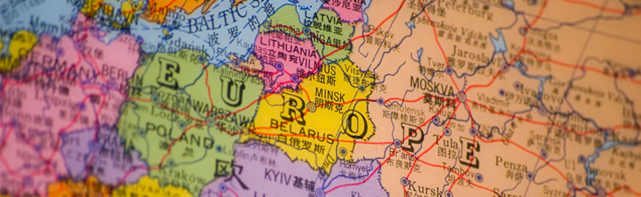

An External View into Europe’s Economy

Arnav Goswami and Tabin Dharanikota

A Real World View of Applied Math and Statistics

Dr. John Taylor and Mrs. Desiré Taylor

Summer Ventures in Science and Mathematics

The University of North Carolina at Charlotte

8/1/2015



**Abstract**

Recently, the economy of Greece collapsed, and the country was on the verge of filing for bankruptcy. The banks of Greece temporarily closed, and reopened the week of 7-20-2015, causing a major scare throughout the country. However, many other countries in Europe such as Luxembourg and Germany seem to be thriving at the same time. Many of these European countries that are thriving are comprised of very similar characteristics and terrains to those of Greece, yet are performing vastly different. The purpose of this study was to determine if there is anything vastly different behind the scenes in the way that Greece’s economy is functioning. Data from 30 European nations was collected, consisting of average work hours, government spending as a percentage of GDP, GDP per capita, social program spending as a percentage of GDP, tax rates, and unemployment rates. With this data, countries were compared, and hypothesis testing as well as linear correlation/regression testing was performed in order to determine the differences and similarities between Greece and the rest of Europe. In the end, it was concluded that there were several statistical and economical differences between Greece and the rest of the European nations. These differences included extraordinarily high tax rates, unemployment rates, government spending, high inflation rates and low GDP per capita. In conclusion, it was found that there are several economic policies that Greece has in effect that are negatively impacting their economy, which are nowhere to be found in the economies of other thriving European nations.